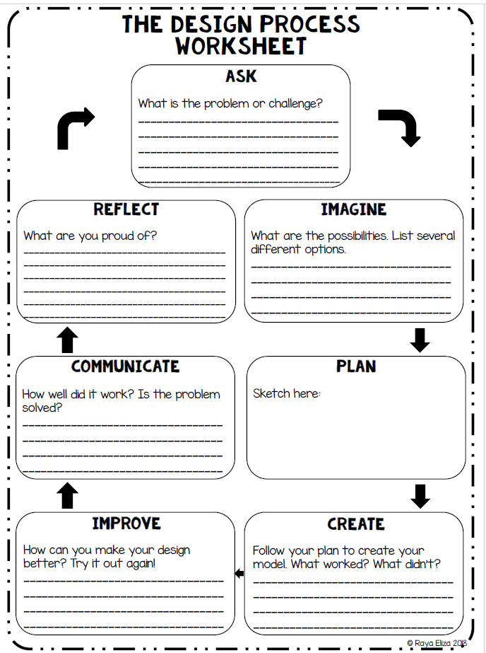
Is the problem/idea solved successfully? Share your project with a classmate, explain your thoughts and how you came to your solution.
Share
Evaluate & Refine
Use your ideas and sketches to create your final project. Think about what works and what doesn’t.
BUILD
DESIGN
Draw at least 3 different sketches of your project plan. Use sketchbook paper for this step. Be sure your ideas are different from one another. Don’t forget to include your thoughts on environment and color.
What are the possibilities? Write down the main project criteria. Then, list different ideas for your project idea.
What’s the Problem/idea for this project?

